Student Attendance Manager
Python Mini Project Report
Name: ______Kiran S____________________
USN: ____________1BG24BA054______________
Course: Python Programming
Date: January 2025

1. Introduction
The Student Attendance Manager is a menu-driven console-based Python application designed to help students efficiently track and manage their class attendance. Maintaining attendance manually can be error-prone and confusing, especially when multiple subjects are involved. This project provides a simple digital solution to record attendance, calculate percentages, and identify subjects where attendance falls below the required threshold.

2. Problem Statement
Students often struggle to track their attendance accurately across multiple subjects. Manual tracking may lead to miscalculations, missed warnings, and last-minute realization of attendance shortages. This project aims to solve this problem by providing an automated and reliable attendance management system.

3. Objectives
- To record attendance as present or absent
- To calculate subject-wise attendance percentage
- To identify subjects below 75% attendance
- To store attendance records permanently using files
- To provide an easy-to-use menu-driven interface

4. System Design and Approach
The application uses a list of dictionaries as its primary data structure. Each dictionary represents one attendance record containing subject name, date, attendance status, and timestamp. The program is menu-driven and runs continuously until the user chooses to exit.

5. Technologies Used
- Python 3
- Jupyter Notebook
- pandas library
- openpyxl library
- datetime module

6. Modules and Functions Description
The project is divided into multiple functions for modularity and clarity:
• mark_attendance(): Records attendance for a subject
• show_all_subjects(): Displays attendance summary
• view_all_records(): Displays all attendance records
• search_by_subject(): Searches records by subject
• calculate_percentage(): Calculates attendance percentage
• show_warnings(): Shows subjects below 75%
• delete_record(): Deletes an attendance record
• load_data(): Loads data from Excel file
• save_data(): Saves data to Excel file

7. File Handling
The application uses an Excel file named attendance.xlsx for data storage. All attendance records are loaded when the program starts and saved when the user exits. This ensures data persistence across multiple runs.

8. Screenshots / Output Demonstration
The following screenshots should be included:
1. Program start and main menu
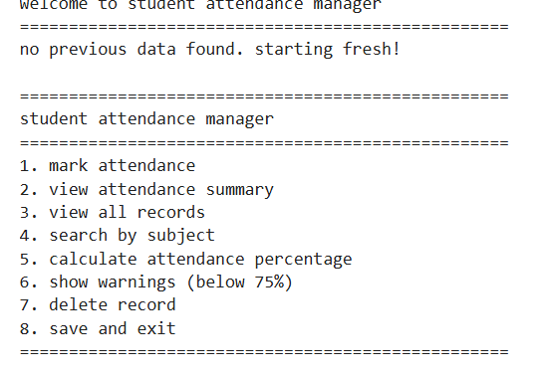
2. Marking attendance
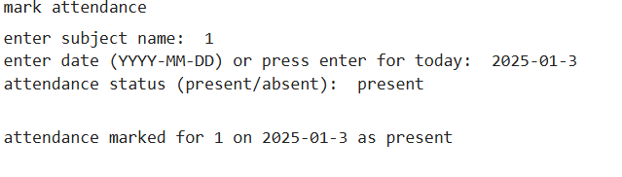

3. Attendance summary view
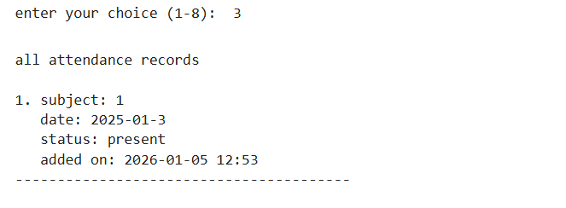
4. Attendance warning output
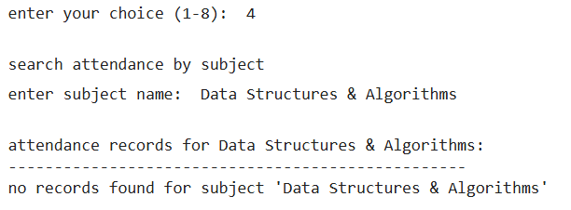
5. Viewing all records
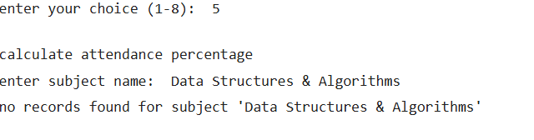
6. Excel file showing saved data

9. Results and Output
The program successfully records attendance, calculates percentages, and displays warnings for low attendance. It ensures accurate tracking and reliable data storage using Excel files.

10. Conclusion
The Student Attendance Manager simplifies attendance tracking and helps students stay informed about their attendance status. The project effectively demonstrates the use of Python fundamentals, data structures, functions, file handling, and exception handling.

11. Future Enhancements
- Add graphical user interface (GUI)
- Generate attendance reports and charts
- Support multiple student profiles
- Add notification alerts for low attendance

